4rd CHORUS Symposium

Transmedial Reception
of Ancient Drama
Université Grenoble Alpes (UGA)

Thursday 26th - Friday 27th March 2026
MaCI – Maison de la Création et de l’Innovation (Amphithéâtre)
Pour suivre la conférence en ligne, lien zoom sur demande à l’adresse suivante : receptionchorus@gmail.com


R. Magritte, La Peine Perdue (1967)

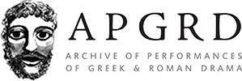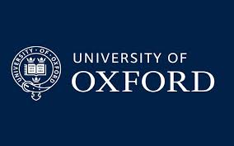 | 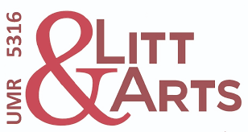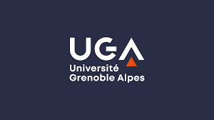 | 
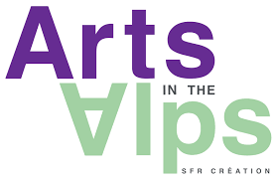 | 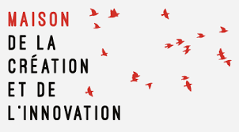 | 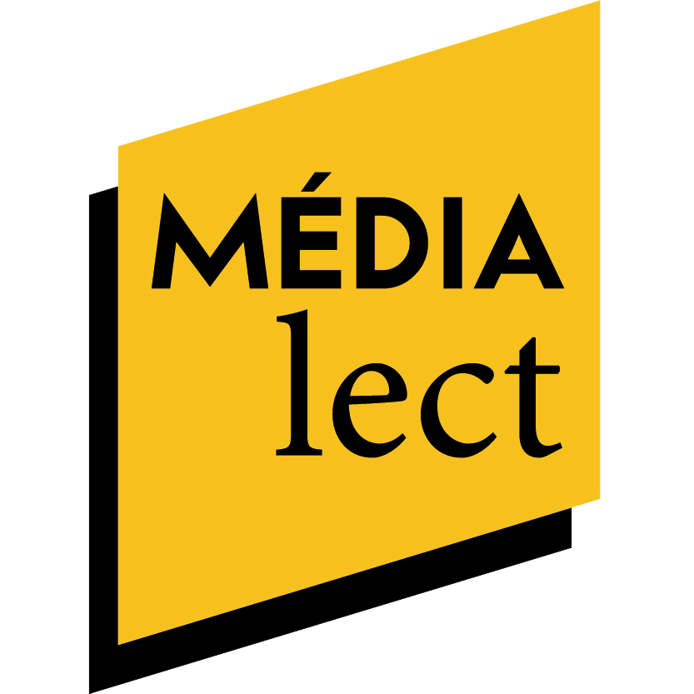

THURSDAY 26th MARCH

9.00 – Welcome

9.30 Transmedial Ripples of the Classical Past

Chella Ward (Open University) Towers and Transmediality: Meeting the Persians in the 9/11 Museum
Hossein Tavazonizadeh / Eleftheria Ioannidou (University of Groningen) The Reception of Ancient Sources from a Cultural Memory Perspective: Antiquities in the Alternative Modernities of Iran and Greece
Tommaso Suaria (University of Lisbon) Greek Dramatic Festivals and Brazilian Samba Contests: polysemy and politics
10.30-11.00 – discussion
Coffee break

11.15 Intermedial Choruses

Małgorzata Budzowska (University of Łódź) Impossible Mourning Becomes Antigone. Sounding The Tragic in Antigone in Molenbeek
Maria Konomi (University of Athens) Challenges and Transformations of the Chorus in New Digital Media
12.00 -12.30 – discussion
Lunch

14.00 Medial Transposition and Resistance
Oliver Baldwin (University of Madrid) A kiss out-on stage: Rau’s Orestes in Mosul
Clara Daniel (AMU) “No Peace, No Pussy!”: Theatricality and Political Engagement in Chi-Raq by Spike Lee.
Marcus Bell (KCL) Dan Lie rotting, intermediality and the tragic
15.00-15.30 – discussion
Coffee break

15.45 Work in Progress I : Ancient Characters in New Contexts

Arsène Cazé (University Paris Nanterre) Menelaus as a problematic protagonist on the contemporary stage
Anaïs Tillier (UGA) From tragedy to “pop cultural activism”: the face of ancient heroines
Magdalena Bournot (UGA / GATES) - Étrangère chez soi. Les réécritures de Médée en Amérique latine (1950-2016)
16.15-16.45 – discussion
Coffee break

17.00 Sensory Transmediations (Live Arts Fab)

Cécile Dudouyt (USPN) Channeling the Past : Language Functions and Intermediality
Maria Constantinou (University Paris Nanterre) Contemporary Dance and Classical Reception: Intergenerational Dialogue Between Zouzou Nikoloudi and Dimitris Papaïoannou
Marie-Louise Crawley (Coventry University) The Isadora Project: Reinscribing Dance History
18.30-19h00 – discussion / PERFORMANCE
FRIDAY 27th MARCH

9.00 – Welcome

9.30 Transmedial Networks

Charitini Tsikoura (University of Paris Nanterre) Rewriting, Rerouting, Re-identifying. Afterlives of Mythic Women Choreographed Today.
Laura Monros Gaspar (University of Valencia) Transmediality, classical receptions and the concept of ‘multiple geographies’ in Victorian London
Cassandre Martigny (Sorbonne Université) Reinterpretations of Medea in contemporary visual arts:
war, motherhood and female resistance
10.30-11.00 – discussion
Coffee break

11.15 Semiotic Transmediations

Alena Sarkissian (Czech Academy of Sciences) A Playwright of the Crossroads: Aristophanes in the post-war Czechoslovakia 1945–48
Daniel Whittle (University of Oxford) Possibility from Dispossession: The Use of Graeco-Roman Imagery in Narratives of Enslavement, 1773–1865
12.00-12.30 – discussion
Lunch

13.30 Work in Progress II : Greek Tragedy in Early Modern Strasbourg

Giovanna Di Martino (APGRD) / Anne Morvan (University of Nantes) /Alexia Dedieu (Aix Marseille University) Greek Tragedy in Strasbourg (1540-1609): Performance, Pedagogy, and Translation
14.00-14.30 – discussion
Coffee break

14.45 Work in Progress III : Greek Tragedy in Lisbon Today

Sofia Frade (University of Lisbon) / Maria Carneiro (Teatromosca) / Sara de Castro (actor and director)
Uses of Ancient Drama in contemporary Portuguese theatre
15.15-15.45 – discussion

16.00 – PLENARY

